Request 객체

**I. 실습**

[조건]

Annotation 방식 및 web.xml 방식 모두 구현하기

[결과]

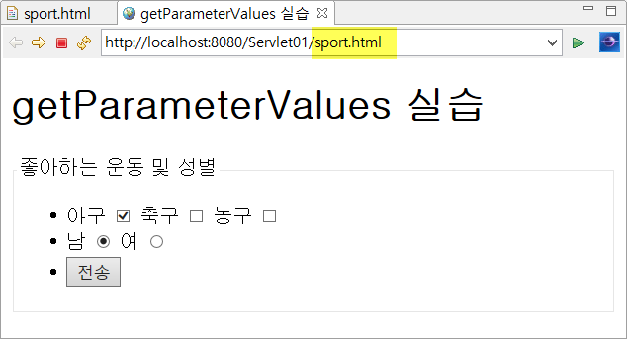 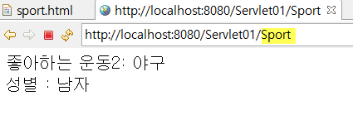

|  |
| --- |
| <!DOCTYPE html>  <html>  <head>  <meta charset=*"UTF-8"*>  <title>getParameterValues 실습</title>  </head>  <body>  <h2>getParameterValues 실습</h2>  </body>  </html> |

[SportServlet.java]

|  |
| --- |
| **package** request.param;  **import** java.io.IOException;  **import** java.io.PrintWriter;  **import** javax.servlet.ServletException;  **import** javax.servlet.annotation.WebServlet;  **import** javax.servlet.http.HttpServlet;  **import** javax.servlet.http.HttpServletRequest;  **import** javax.servlet.http.HttpServletResponse; |

**II. 실습**

[조건]

Anotation 및 XML 방식 모두 구현하기

[결과]

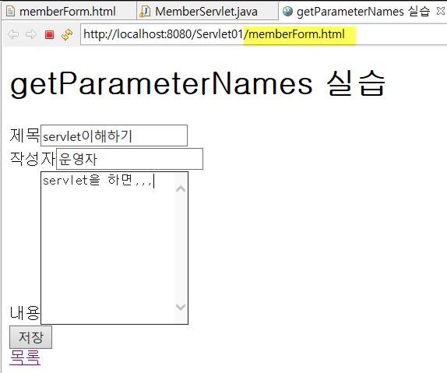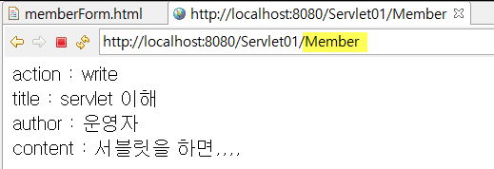

|  |
| --- |
| <!DOCTYPE html>  <html>  <head>  <meta charset=*"UTF-8"*>  <title>getParameterNames 실습</title>  </head>  <body>  <h1>getParameterNames 실습</h1>  </body>  </html> |

[MemberServlet.java]

|  |
| --- |
|  |